Rodrigo Brasil 10/2023

### **Part 1: Topology 1/2**

Read through the entire lab and use Draw.io to create an appropriate topology of the network you expect to construct. Include as many details as you can such as computer names, OS types, IP addresses, etc. Include a screenshot of this initial topology.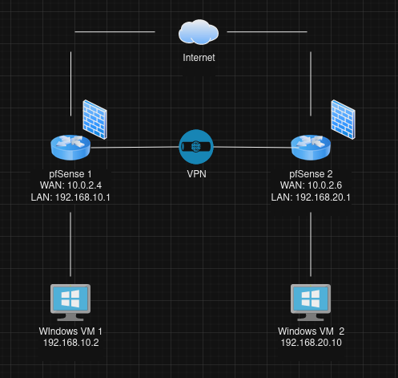

### **Part 2: Staging the Networks**

This lab requires that you’ve established a VPN tunnel between two pfSense networks in VirtualBox.

* Share a folder on the Corporate Windows 10.
* From another VM on the Corporate (internal) network, access the shared folder. Create a file. Include a screenshot of this operation.
* From External Windows 10, access the shared folder via VPN. Create a file. Include a screenshot of this operation.
* On each Windows 10, [create a firewall rule to allow ICMP traffic](https://www.how2shout.com/how-to/allow-windows-10-ping-through-firewall-gui-powershell-netsh-command.html). This will make testing your network easier, and will help you diagnose problems with you network vs problems with the fileshare.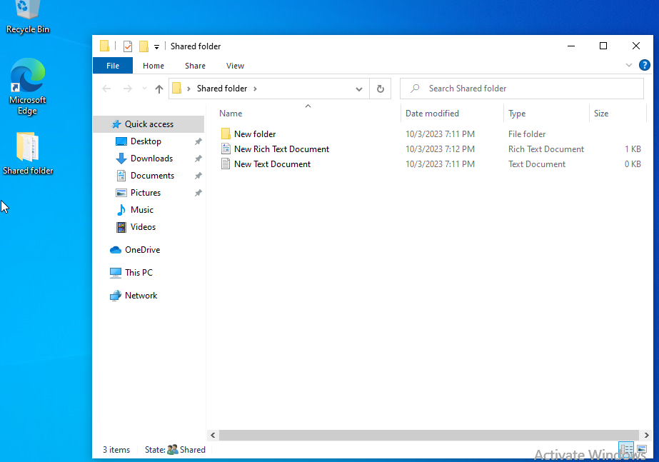

Windows10 VM 1 Sharing the folder

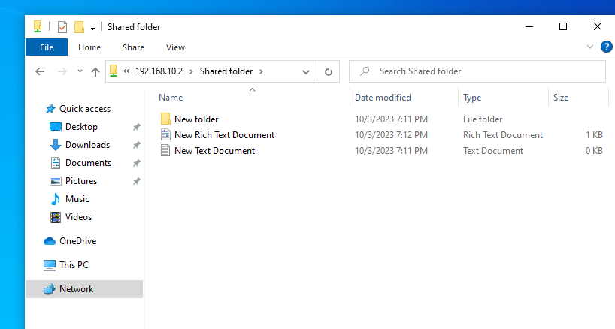

Windows10 VM 2 accessing the shared folder

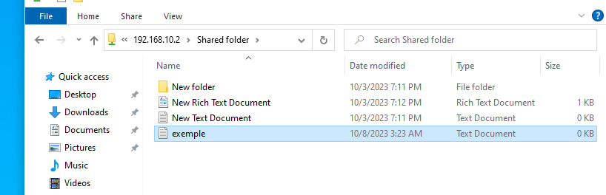

On Windows10VM 2 created a text file called “exemple”

text file “exemple” in the shared folder on windows10 VM 1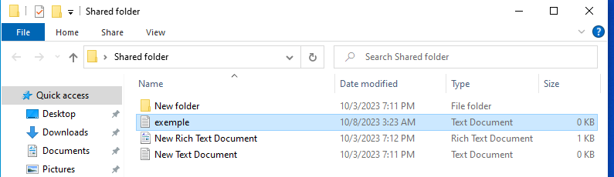

### **Part 3: Configuring the Networks**

Now that we have established normal comms between the networks, and know that the file share is working, let’s start experimenting with NAT. We can use a 1:1 NAT rule in pfSense to convert the IP address of our Corporate Windows 10 for VPN users.

* In pfSense, utilize 1:1 NAT to convert the file server IP to a different IP if accessed via VPN tunnel.
* To accomplish this, you can use the 1:1 NAT features built into IPsec VPN in pfSense.
* Include a screenshot of your configuration.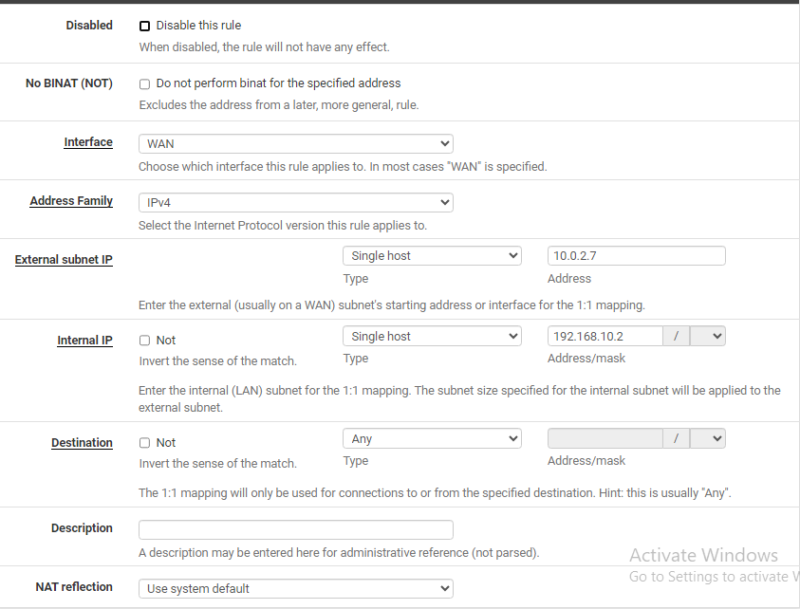

1:1 NAT configuration on pfSense 1

1:1 NAT configuration on pfSense 2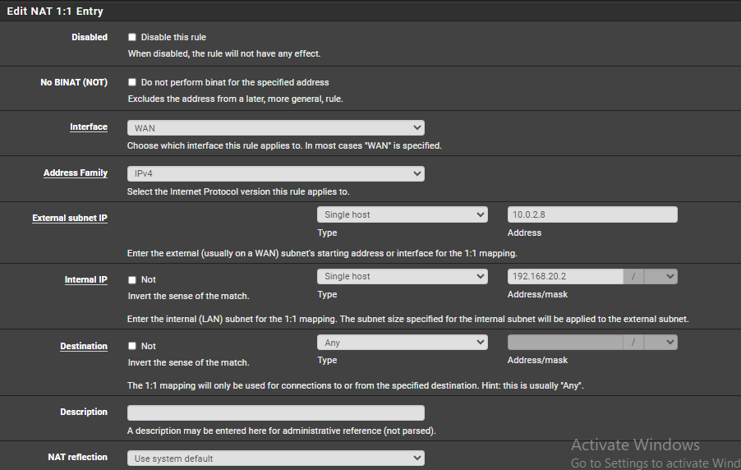

### **Part 4: Testing**

Now let’s test and verify that the NAT is translating the IP address correctly and that we can access the shared folder from the External Windows 10.

* Mount the file share on the External Windows 10.
* Include a screenshot of successfully accessing the file share in Windows Explorer.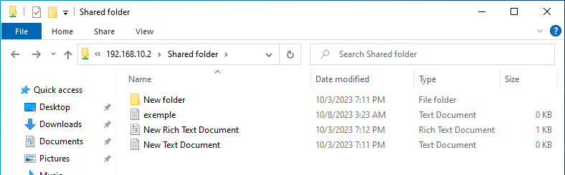

Accessing the shared file in the Windows10 VM 2

### 

### **Part 5: Topology 2/2**

When the other tasks are complete, review the topology and update, revise, extend, or add details as necessary.

